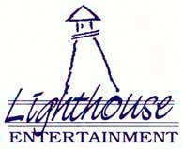
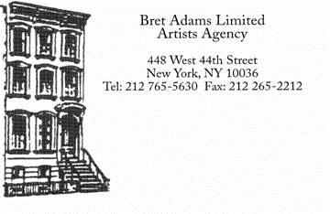
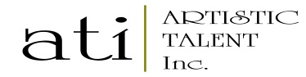

HENRY HEREFORD
SAG – AFTRA

TELEVISION
Crossbones (2 Roles S1) Guest Star +Recurring Guest Star NBC/ Dir: David Slade/ Various True Blood Co-Star HBO/ Dir: Romeo Tirone
Happily Divorced Co-Star TV Land/ Dir: Peter Marc Jacobson
Liz and Dick (TV Movie) Supporting Lifetime Network
True Jackson VP Co-Star Nickelodeon
The Alice Recurring Channel 9 Australia
The Bill Guest Star BBC
Casualty Guest Star BBC

FILM
The Girl with the Dragon Tattoo Supporting Sony/Dir: David Fincher
Liars All Supporting Indie Ent/Dir: Brian Brightly
Murderous Intent Supporting BBC/AFC

THEATRE
Woyzeck Multiple Off Broadway
An Artist’s Point of View Lead Newtown Theatre Sydney
Remember Lead West End: Jermyn Street
Country Wife Lead Young Vic Theater London
Today Review Multiple Canal Café London

COMMERCIALS
Conflicts available on request
VOICE-OVER
Please contact William Morris Endeavor

TRAINING
3 years Acting Diploma Drama Studio, London
Private Coaching Paul Duddridge, Hank Berrings, Los Angeles
Improv UCB 301, Los Angeles

SKILLS
Accents: British (most regional dialects including R.P. and Scottish), Irish, French, German, American (Standard Southern, Australian, New Zealand and South African
Sports: Paddle Boarding, Running (cross country)

WORK AUTHORIZATION
United States Green Card: Permanent Resident
Europe United Kingdom Passport
Australia and New Zealand New Zealand Passport

LIGHTHOUSE ENTERTAINMENT: STEVEN SIEBERT
Phone: 310 2460499

artistic talent: annette robinson
Phone: 323 206 7807

